WORKSHEET · CAMBRIDGE IGCSE PHYSICS 0625 · 1.2 MOTION (CORE)

Acceleration of free fall, g: practice
Six original questions on free fall and the acceleration g. Give a unit with every answer. Take g = 9.8 m/s squared unless a question says otherwise.
Name: ________________ Class: __________ Date: __________
Q1. (a) State the approximate value of the acceleration of free fall g near the Earth, with its unit. (b) State what is meant by free fall. [2]

Q2. A hammer and a feather are dropped together inside a tube with the air removed. State what is seen, and explain why. [2]

Q3. Taking g = 10 m/s squared, a stone falls from rest. (a) Find its speed after 3 s. (b) Find its speed after 5 s. [3]

Q4. The speed-time graph below shows an object in free fall (taking g = 10 m/s squared). [4]
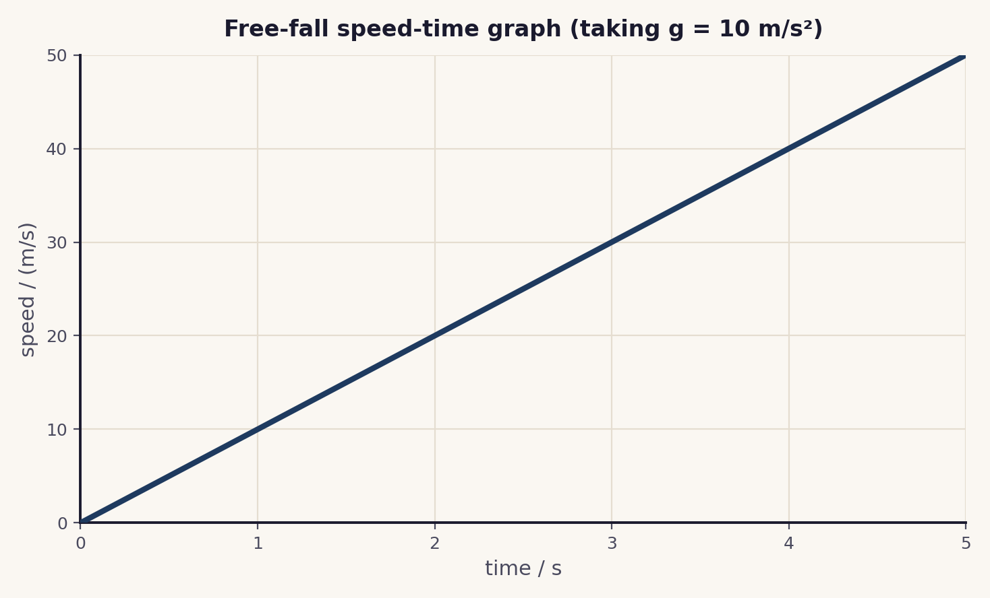
(a) Describe the motion shown. (b) Find the gradient of the line and state what it represents. (c) What is the speed after 2 s?

Q5. A feather falls slowly in air, but a stone falls quickly. A student says “gravity is stronger on the stone.” Explain why this is wrong. [2]

Q6. Taking g = 9.8 m/s squared, find the speed of a freely falling object 2 s after it is released from rest. [2]

Total: 15 marks. Original work by the TheLucidSTEM team. Written in the style of the papers; no past paper question is reproduced.
ANSWER KEY · FULL WORKED SOLUTIONS

Acceleration of free fall, g: answers
Q1. The value of g and free fall.
(a) g is about 9.8 m/s² (10 m/s² is accepted).
(b) free fall is motion under gravity alone, with no air resistance.
Q2. Hammer and feather in a vacuum.
they fall at the same rate and land together. With no air resistance both have the same acceleration g; the acceleration of free fall does not depend on mass.
Q3. Speed from v = g t.
(a) v = g t = 10 × 3 = 30 m/s.
(b) v = g t = 10 × 5 = 50 m/s.
Q4. Reading the graph.
(a) the speed increases at a steady rate from rest: constant acceleration (free fall).
(b) gradient = 50 ÷ 5 = 10 m/s²; it represents the acceleration of free fall, g.
(c) at 2 s the speed is 20 m/s.
Q5. The same g for all.
gravity gives both objects the same acceleration g. The feather is slow because of air resistance, not because gravity is weaker; remove the air and the feather keeps pace with the stone.
Q6. Speed from v = g t.
v = g t = 9.8 × 2 = 19.6 m/s.
Marking note: award the unit mark only when the correct unit is given (m/s for speed, m/s² for g). In Q5, the key idea is that g is the same for all masses and air resistance explains the difference.

