WORKSHEET · CAMBRIDGE IGCSE PHYSICS 0625 · 1.2 MOTION (CORE)

Distance-time graphs: practice
Six original questions on reading and sketching distance-time graphs. Remember: the gradient is the speed, and a horizontal line is stationary.
Name: ________________ Class: __________ Date: __________
Q1. State what each of these shows on a distance-time graph: (a) a horizontal line; (b) a straight line that slopes upwards. [2]

Q2. The distance-time graph below shows a short journey. [4]
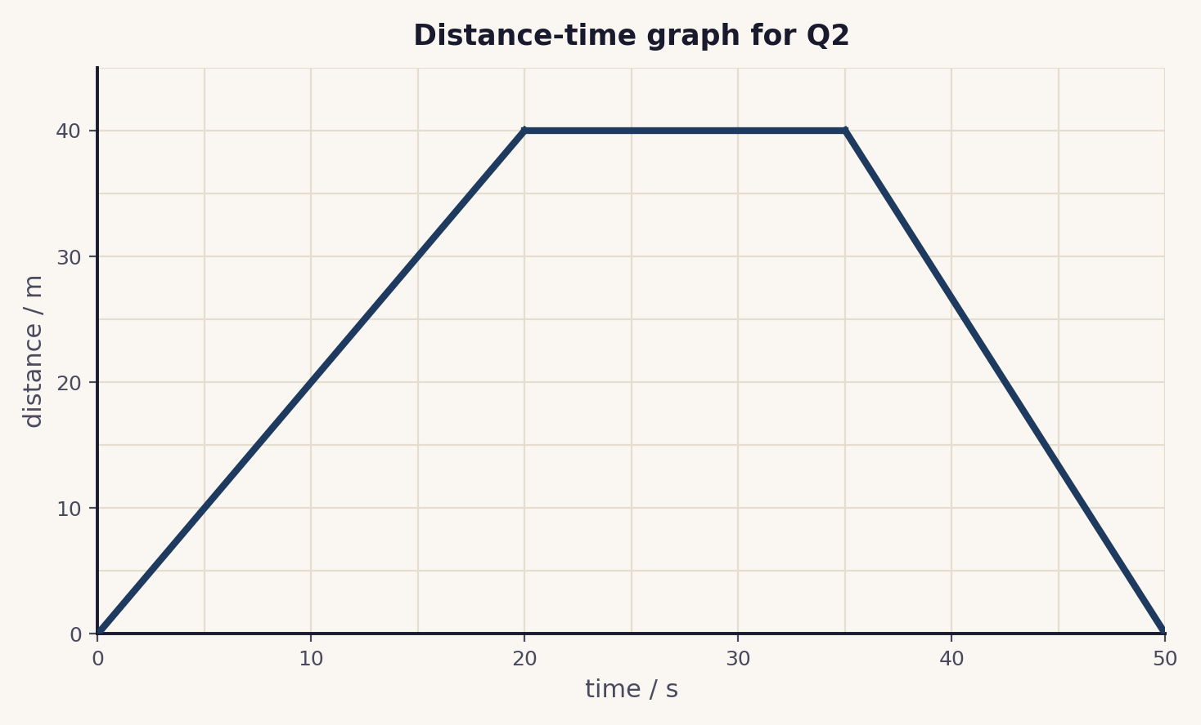
(a) Describe the motion between 20 s and 35 s.
(b) Calculate the speed during the first 20 s.
(c) Is the object faster or slower on the way back than on the way out? Give a reason.

Q3. A student says, “a horizontal line on a distance-time graph means the object moves at constant speed.” Explain why this is wrong, and state what a horizontal line really means. [2]

Q4. Sketch a distance-time graph for this journey: stationary for 10 s, then a constant speed away from the start for 20 s. Label the axes. [3]

Q5. On a distance-time graph an object moves from 10 m to 70 m between 5 s and 25 s. Calculate its speed. [2]

Q6. Describe the motion shown by (a) a curve that gets steeper, and (b) a curve that gets less steep. [2]

Total: 15 marks. Original work by the TheLucidSTEM team. Written in the style of the papers; no past paper question is reproduced.
ANSWER KEY · FULL WORKED SOLUTIONS

Distance-time graphs: answers
Q1. Reading the lines.
(a) a horizontal line means the object is stationary (the distance is not changing).
(b) a straight sloped line means a constant speed.
Q2. Reading the graph.
(a) between 20 s and 35 s the line is horizontal, so the object is stationary.
(b) speed = gradient = 40 ÷ 20 = 2 m/s.
(c) faster on the way back: the return covers 40 m in 15 s (about 2.7 m/s), a steeper line than the outward 40 m in 20 s.
Q3. The horizontal-line trap.
a horizontal line is not constant speed. The distance is not changing, so the object is stationary. Constant speed is shown by a straight line that slopes upwards.
Q4. Sketch.
expected shape: a horizontal line for the first 10 s (stationary), then a straight line sloping upwards for the next 20 s (constant speed). Axes labelled distance / m against time / s.
Q5. Speed from the graph.
speed = gradient = (70 − 10) ÷ (25 − 5) = 60 ÷ 20 = 3 m/s.
Q6. Curved lines.
(a) a curve that gets steeper shows the object speeding up.
(b) a curve that gets less steep shows the object slowing down.
Marking note: in Q2(b) and Q5, the gradient must be read with a large triangle and the unit m/s given. In Q4, award for the horizontal section, the sloped section, and labelled axes.

