WORKSHEET · CAMBRIDGE IGCSE PHYSICS 0625 · 1.2 MOTION (EXTENDED)

Gradient and area: practice
Six original Extended questions on reading a speed-time graph. Remember: the gradient is the acceleration, and the area under the line is the distance. Give a unit with every answer.
Name: ________________ Class: __________ Date: __________
Q1. From a speed-time graph, state how you would find (a) the acceleration, and (b) the distance travelled. [2]

Q2. The speed-time graph below shows a journey. Use it for Q2 to Q4. [3]
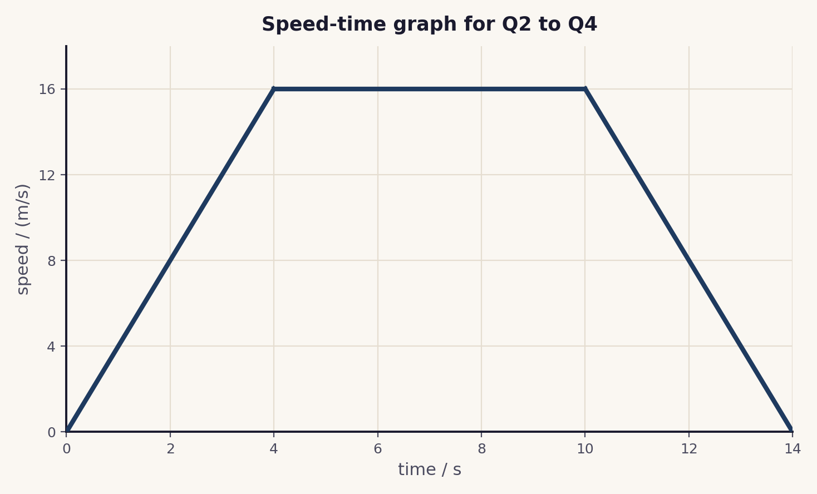
(a) Calculate the acceleration during the first 4 s. (b) Describe the motion between 4 s and 10 s.

Q3. Calculate the total distance travelled, by finding the area under the line. Show how you split the area. [4]

Q4. Calculate the deceleration during the last 4 s. [2]

Q5. A car accelerates uniformly from 5 m/s to 25 m/s in 8 s. Calculate its acceleration. [2]

Q6. A train travels at a constant 30 m/s for 40 s. Use the area under its speed-time graph to find the distance travelled. [2]

Total: 15 marks. Original work by the TheLucidSTEM team. Written in the style of the papers; no past paper question is reproduced.
ANSWER KEY · FULL WORKED SOLUTIONS

Gradient and area: answers
Q1. The two readings.
(a) the acceleration is the gradient of the line (use a large triangle, a = Δv ÷ Δt).
(b) the distance travelled is the area under the line.
Q2. Acceleration and the steady stage.
(a) a = Δv ÷ Δt = 16 ÷ 4 = 4 m/s².
(b) between 4 s and 10 s the line is horizontal at 16 m/s: constant speed.
Q3. Distance from the area.
split into a triangle, a rectangle and a triangle:
triangle (0 to 4 s): ½ × 4 × 16 = 32 m.
rectangle (4 to 10 s): 6 × 16 = 96 m.
triangle (10 to 14 s): ½ × 4 × 16 = 32 m.
total distance = 32 + 96 + 32 = 160 m.
Q4. Deceleration.
a = Δv ÷ Δt = (0 − 16) ÷ 4 = −4 m/s², so the deceleration is 4 m/s².
Q5. Uniform acceleration.
a = Δv ÷ Δt = (25 − 5) ÷ 8 = 20 ÷ 8 = 2.5 m/s².
Q6. Distance from a rectangle.
distance = area = 30 × 40 = 1200 m.
Marking note: in Q3 award for splitting the area and for the correct total. Give the unit mark only when m/s² (acceleration) or m (distance) is stated.

