WORKSHEET · CAMBRIDGE IGCSE PHYSICS 0625 · 1.1 MEASUREMENT

Measuring length and volume: practice
Six original questions on choosing instruments, reading scales, and units. Give a unit with every answer.
Name: ________________ Class: __________ Date: __________
Q1. Choosing the instrument. Name the instrument you would use to measure each of the following. [3]
(a) the volume of about 50 cm³ of water
(b) the length of a pencil
(c) the volume of a small, irregular stone

Q2. Units and prefixes. Convert each measurement. [3]
(a) 2.5 m into cm
(b) 45 mm into cm
(c) 250 cm³ into dm³ (1 dm³ = 1000 cm³)

Q3. Reading a rule. The diagram shows a metal rod measured against a rule. State the length of the rod in (a) cm and (b) mm. [2]
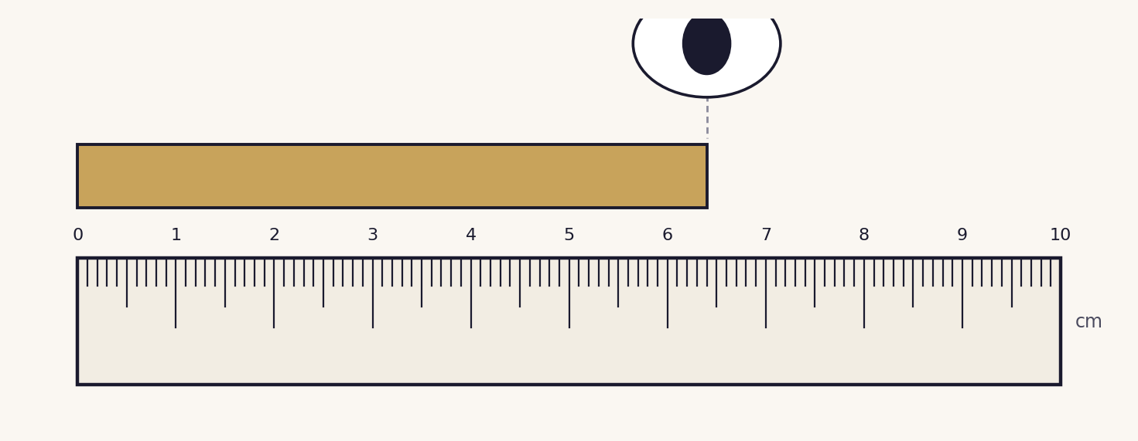

Q4. Reading a measuring cylinder. The diagram shows water in a measuring cylinder. State the volume of the water, and state where on the scale you read it. [2]
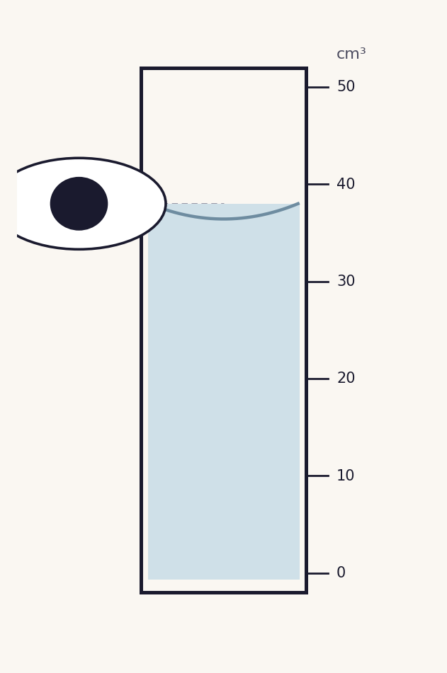

Q5. Volume by displacement. A stone is lowered into a measuring cylinder of water. The diagrams show the level before and after. [3]
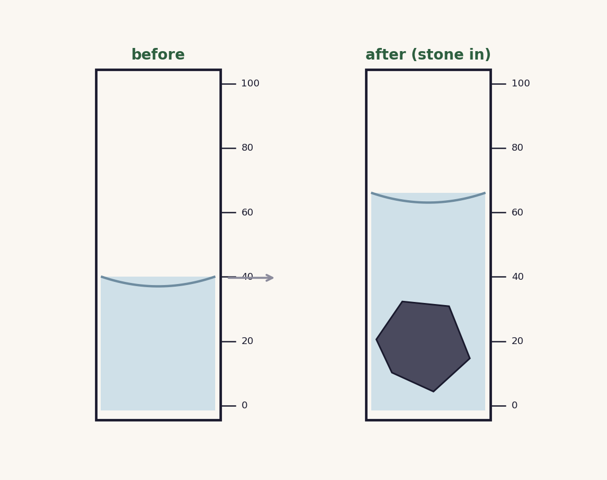
(a) State the volume of the stone.
(b) Explain why the stone must be fully submerged.
(c) Give one precaution that makes the reading more accurate.

Q6. Accuracy. A learner says, “a longer ruler always measures more accurately.” State whether this is correct and explain your answer using the idea of the smallest division. [2]

Total: 15 marks. Original work by the TheLucidSTEM team. Written in the style of the papers; no past paper question is reproduced.
ANSWER KEY · FULL WORKED SOLUTIONS

Measuring length and volume: answers
Q1. Choosing the instrument.
(a) a measuring cylinder.
(b) a rule (ruler).
(c) a displacement (eureka) can, with a measuring cylinder to collect the water.
Q2. Units and prefixes.
(a) 2.5 m = 2.5 × 100 = 250 cm.
(b) 45 mm = 45 ÷ 10 = 4.5 cm.
(c) 250 cm³ = 250 ÷ 1000 = 0.25 dm³.
Q3. Reading a rule.
(a) 6.4 cm. (b) 64 mm. Accept 6.3 to 6.5 cm read square to the eye.
Q4. Reading a measuring cylinder.
38 cm³ (accept 37 to 39 cm³). Read the bottom of the meniscus, with the eye level with the liquid.
Q5. Volume by displacement.
(a) volume of stone = 66 − 40 = 26 cm³.
(b) so that the water it pushes aside equals the whole volume of the stone.
(c) any one: read at eye level / read the bottom of the meniscus / no trapped air bubbles on the stone.
Q6. Accuracy.
Incorrect. Accuracy depends on the smallest division and careful reading, not the length of the ruler. A rule marked in millimetres is more precise than one marked only in centimetres, whatever their overall lengths.
Marking note: in Q3 and Q4, accept readings within the stated range; award the unit mark only when a correct unit is given. In Q5(a), the method (final minus initial) must be shown.

