WORKSHEET · CAMBRIDGE IGCSE PHYSICS 0625 · 1.1 SUPPLEMENT (EXTENDED)

Resultant vectors: practice
Six original questions on combining two perpendicular vectors. Show your working, and give every resultant a magnitude and a direction.
Worked reference: 3 N east and 4 N north combine to 5 N, not 7 N.
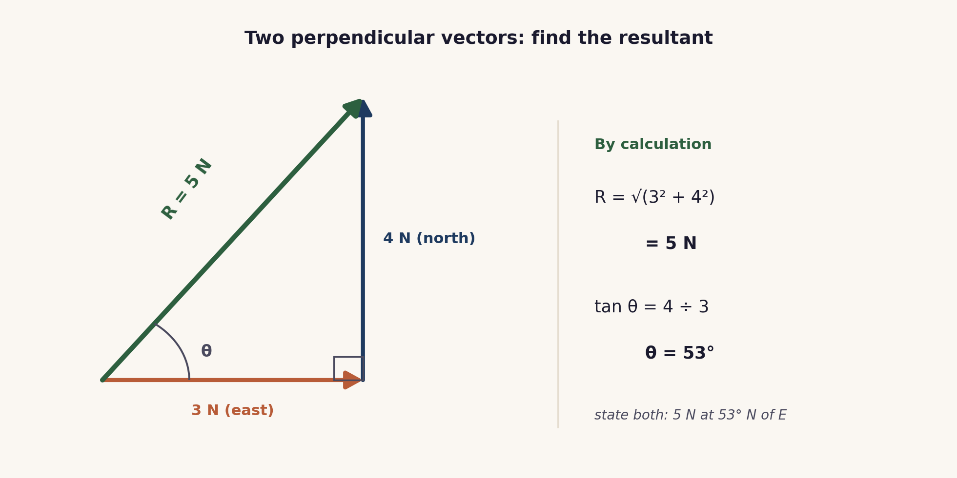
Name: ________________ Class: __________ Date: __________
Q1. Two perpendicular forces, 3 N and 4 N, act on a point (see above). State the resultant, and explain why it is 5 N and not 7 N. [2]

Q2. Two perpendicular forces act on a point: 6 N east and 8 N north. [3]
(a) Calculate the magnitude of the resultant.
(b) Calculate the angle it makes north of east.

Q3. A swimmer heads due north at 5 m/s. A current carries them due east at 12 m/s. [3]
(a) Calculate the resultant speed.
(b) Calculate the direction, as an angle east of north.

Q4. Scale drawing. Two perpendicular forces of 30 N and 40 N act on a point. [3]
(a) State a suitable scale for a drawing.
(b) On the drawing the resultant measures 5.0 cm. State the force this represents.
(c) Confirm the magnitude by calculation.

Q5. A resultant of 13 N is made from two perpendicular components. One component is 5 N. Calculate the other component. [2]

Q6. (a) State the two things every resultant answer must include. (b) Give one reason a scale-drawing answer may differ slightly from a calculated one. [2]

Total: 15 marks. Original work by the TheLucidSTEM team. Written in the style of the papers; no past paper question is reproduced.
ANSWER KEY · FULL WORKED SOLUTIONS

Resultant vectors: answers
Q1. 3 N and 4 N at right angles.
Resultant = 5 N. Perpendicular vectors do not add arithmetically: combine with Pythagoras, √(3² + 4²) = 5 N. The resultant also needs a direction, so 3 + 4 = 7 is wrong on both counts.
Q2. 6 N east and 8 N north.
(a) R = √(6² + 8²) = √100 = 10 N.
(b) tan θ = 8 ÷ 6, so θ = 53° north of east.
Q3. Swimmer and current.
(a) resultant = √(5² + 12²) = √169 = 13 m/s.
(b) tan θ = 12 ÷ 5, so θ = 67° east of north.
Q4. Scale drawing of 30 N and 40 N.
(a) a suitable scale is 1 cm to 10 N.
(b) 5.0 cm represents 5.0 × 10 = 50 N.
(c) by calculation, R = √(30² + 40²) = √2500 = 50 N, which agrees.
Q5. Missing component.
other component = √(13² − 5²) = √(169 − 25) = √144 = 12 N.
Q6. Stating a resultant.
(a) a magnitude (size) and a direction.
(b) a scale drawing depends on the accuracy of the ruler and protractor, so it carries measurement error and is only approximate.
Marking note: in Q2, Q3 and Q4(c), the use of Pythagoras must be shown. A direction is required wherever a resultant is asked for.

