LESSON PLAN · CAMBRIDGE IGCSE PHYSICS 0625 · EXTENDED (SUPPLEMENT)

Scalars and vectors: a direction, or just a number?
The first Extended lesson of the course: define a scalar and a vector, and classify quantities by asking one question of each, does it need a direction?
Topic | Scalars and vectors (Lesson 3 of subtopic 1.1)
Syllabus reference | Cambridge IGCSE Physics 0625, 1.1 Supplement (Topic 1: Motion, forces and energy)
Level | Extended (Supplement). This is the first Extended lesson of the course.
Duration | 45 minutes, card based. About 40 to 45 minutes of material; scales to a 60 minute block
Position in scheme | Unit 1.1, Lesson 3. Follows Lesson 2 (measuring time); leads into Lesson 4 (resultant of two perpendicular vectors).
Central visual model | The arrow board: vectors drawn as arrows, scalars written as plain labels
Simulation | The Round Trip Trap (Unit 1 site simulation): distance and speed grow, while displacement and velocity carry a direction
Cooperative structure | A simulation-led hook, then Quiz-Quiz-Trade with quantity cards
Assessment | A classify-and-explain exit ticket, plus random call after the sort

Learning objectives
By the end of the lesson, learners can:
Extended (Supplement)
- define a scalar as a quantity with magnitude only, and a vector as a quantity with magnitude and direction
- classify common quantities: scalars such as distance, speed, time, mass and energy; vectors such as displacement, velocity, acceleration, force, weight and momentum
- explain the difference between distance and displacement, and between speed and velocity, using a journey
- represent a vector as an arrow whose length shows its magnitude and whose direction shows its direction

Key vocabulary
scalar, vector, magnitude, direction, distance, displacement, speed, velocity, acceleration, force, weight, momentum, resultant (previewed for the next lesson). Each term is introduced as it is first needed.

The core visual model
The lesson is built on one picture: the arrow board. A vector is drawn as an arrow, its length the size and its head the direction; a scalar is written as a plain number with a unit. The site simulation The Round Trip Trap feeds straight into it: on a journey out and back, distance and average speed keep growing while displacement and average velocity carry a direction and can return to zero. That contrast is the whole lesson, so every quantity is tested with one question, does it need a direction?
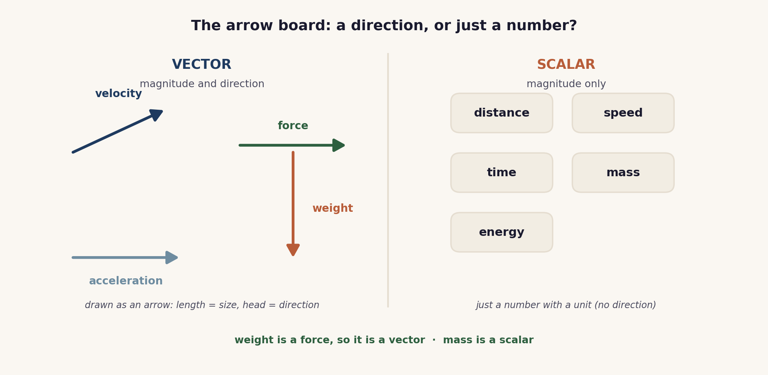
The arrow board. A vector is an arrow with a direction; a scalar is just a number with a unit. Weight is a force, so it is a vector; mass is a scalar.

Lesson sequence (45 minutes)
Time | Phase | What happens in the room | Grouping
0 to 5 min | Hook: the round trip | The site simulation The Round Trip Trap is run on the board. As a journey goes out and back, distance and average speed keep climbing, but displacement and average velocity point in a direction and can fall back to zero. The question lands: which of these quantities need a direction, and which do not? | Whole class, sim on board
5 to 15 min | Build the arrow board | Scalar (magnitude only) and vector (magnitude and direction) are defined. A vector is drawn as an arrow whose length shows its size and whose head shows its direction; a scalar is written as a plain number with a unit. The key quantities are placed on the board, and the pairs that trip learners up are drawn out: speed and velocity, distance and displacement, and weight, which is a force and therefore a vector, against mass, which is a scalar. | Whole class, teacher led
15 to 28 min | Quiz-Quiz-Trade | Each learner holds a quantity card. They find a partner, quiz each other (“scalar or vector, and why?”), coach if needed, then trade cards and find a new partner. The cards mix the core quantities with a few that provoke discussion. | Pairs, moving
28 to 38 min | Sort and justify | In fours, learners sort eight quantity cards onto a scalar and vector mat, then a number is called and that learner justifies one placement. This is the checkpoint: eight quantities sorted and defended. | Groups of four
38 to 45 min | Plenary and exit | Exit ticket: classify a short list of quantities, and explain in one sentence why velocity is a vector but speed is a scalar. Learners self assess against the objectives. | Individual

Timing and contingency
Two card-based blocks follow the build. Quiz-Quiz-Trade must keep moving: give a clear signal to trade, and cap it so the sort and the exit are not squeezed.
- Protected: the exit ticket. It is the only individual check of the Extended outcomes and is not cut.
- If time is short: replace the sort with a quick mini-whiteboard vote (scalar or vector) on six quantities, and keep Quiz-Quiz-Trade as the main cooperative task.
- In a 60 minute block: add a short Jigsaw, with expert pairs on scalars and on vectors teaching each other, and a preview of combining two vectors ready for Lesson 4.

Running the cooperative task
Quiz-Quiz-Trade. Each learner holds one quantity card. They pair up; learner A quizzes learner B, “scalar or vector, and why?”, praises or coaches the answer, and then the roles swap. The pair then trade cards and split off to find new partners. Because the cards keep moving, every learner meets many quantities and has to give a reason each time, not just a label.
Why it suits this lesson. Classifying is quick to say but easy to get wrong, so learners need many short, low-stakes attempts with immediate correction from a peer. Quiz-Quiz-Trade gives exactly that, and the reasons spoken aloud are where the misconceptions surface.

Examiner traps to pre-empt
Trap learners fall into | Teaching move that pre-empts it
Calling speed a vector, or velocity a scalar. | Speed is a scalar: how fast, only. Velocity is speed in a stated direction, so it is a vector. Use the round trip: speed stays positive, velocity changes direction.
Treating distance and displacement as the same. | Distance is the whole path travelled (a scalar). Displacement is the straight line from start to finish with a direction (a vector). A there-and-back journey has distance but zero displacement.
Thinking weight is a scalar like mass. | Weight is the force of gravity, so it is a vector and acts downwards. Mass, the amount of matter, is a scalar.
Giving a vector with no direction. | A vector answer needs a direction as well as a size, for example 5 N to the right, not just 5 N.
Confusing the size of a vector with a plus or minus sign only. | Magnitude is the size and is never negative. Direction can be shown by a sign along a line, by a bearing, or by an arrow.

Differentiation and language support
Support: a two column scalar and vector sorting mat for the cards, and the sentence frame “this is a ... because it has ...”.
Challenge: borderline cards to argue over (temperature, pressure and electric current are treated as scalars at this level), and an early look at combining two vectors into a resultant, ready for Lesson 4.
Language: rehearse “a scalar has magnitude only; a vector has magnitude and a direction” and “velocity is a vector because it has a direction” before learners write.

Assessment
Formative. Quiz-Quiz-Trade gives constant peer checking; the sort with random call tests whether learners can justify a classification, not just recall it; and the exit ticket maps to the Extended objectives.
Original work by the TheLucidSTEM team. Items are written in the style of the papers; no past paper question is reproduced.

Equipment and resources
- printed quantity cards for Quiz-Quiz-Trade and the sort, scalar and vector sorting mats, and mini whiteboards
- the site simulation The Round Trip Trap (Unit 1 simulations, /sims/unit-1/; direct embed at /sims/embeds/unit-1/speed-and-velocity.html), shown on the board for the hook
- the student topic page /igcse/measurement/scalars-and-vectors/, for pre-reading or revision; the quantity cards in this bundle

