WORKSHEET · CAMBRIDGE IGCSE PHYSICS 0625 · 1.1 SUPPLEMENT (EXTENDED)

Scalars and vectors: practice
Six original questions on defining and classifying quantities. Give a direction wherever a quantity is a vector.
Name: ________________ Class: __________ Date: __________
Q1. Define each term. [2]
(a) a scalar quantity
(b) a vector quantity

Q2. Classify each quantity as a scalar (S) or a vector (V): distance, velocity, mass, force, time, displacement, energy, weight. [4]

Q3. A runner travels 100 m due east, then returns 100 m due west to the starting point. [3]
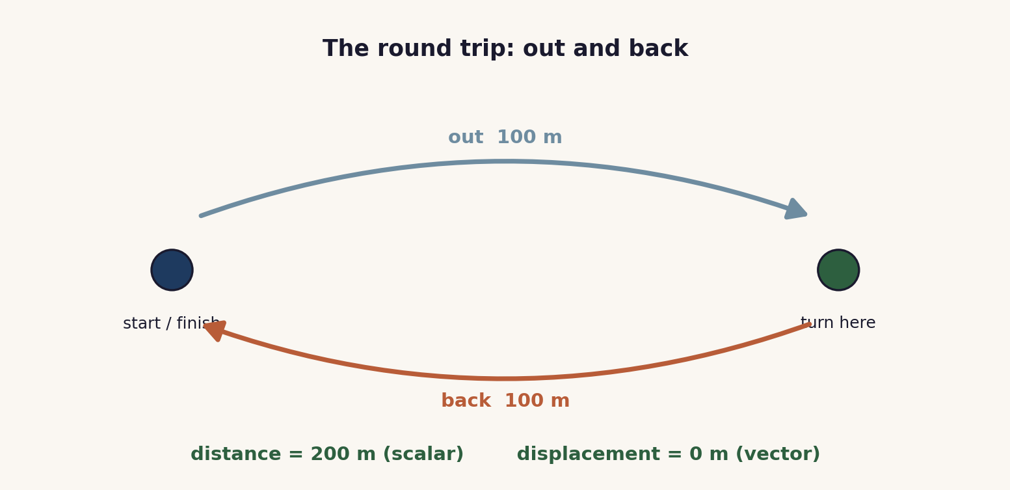
(a) State the total distance travelled.
(b) State the displacement.
(c) Explain why the displacement has that value.

Q4. Explain the difference between speed and velocity. Include an example of each. [2]

Q5. State whether each is a scalar or a vector, and give a reason: (a) mass, (b) weight. [2]

Q6. A force of 6 N acts to the right on a box. [2]
(a) Is force a scalar or a vector?
(b) Describe how you would represent this force as an arrow.

Total: 15 marks. Original work by the TheLucidSTEM team. Written in the style of the papers; no past paper question is reproduced.
ANSWER KEY · FULL WORKED SOLUTIONS

Scalars and vectors: answers
Q1. Definitions.
(a) a scalar has magnitude (size) only.
(b) a vector has magnitude and a direction.
Q2. Classification.
Scalars (S): distance, mass, time, energy.
Vectors (V): velocity, force, displacement, weight.
Marking: 1 mark per two correct, to a maximum of 4.
Q3. The round trip.
(a) total distance = 100 + 100 = 200 m.
(b) displacement = 0 m.
(c) displacement is the straight line from start to finish, with direction. The runner ends where they began, so the displacement is zero, even though the distance is 200 m.
Q4. Speed and velocity.
Speed is how fast something moves, a scalar (for example 30 m/s). Velocity is speed in a stated direction, a vector (for example 30 m/s due north).
Q5. Mass and weight.
(a) mass is a scalar: it is the amount of matter, magnitude only.
(b) weight is a vector: it is the force of gravity and acts downwards, so it has a direction.
Q6. Representing a force.
(a) force is a vector.
(b) draw an arrow pointing to the right; its length represents 6 N to a chosen scale (for example 1 cm to 1 N gives a 6 cm arrow).
Marking note: in Q3(b) and Q5, a vector answer must carry its direction. In Q2, award by correct pairs as shown.

