WORKSHEET · CAMBRIDGE IGCSE PHYSICS 0625 · 1.2 MOTION (CORE)

Speed and velocity: practice
Six original questions on speed and velocity. Show your working and give a unit with every answer. Use v = s ÷ t.
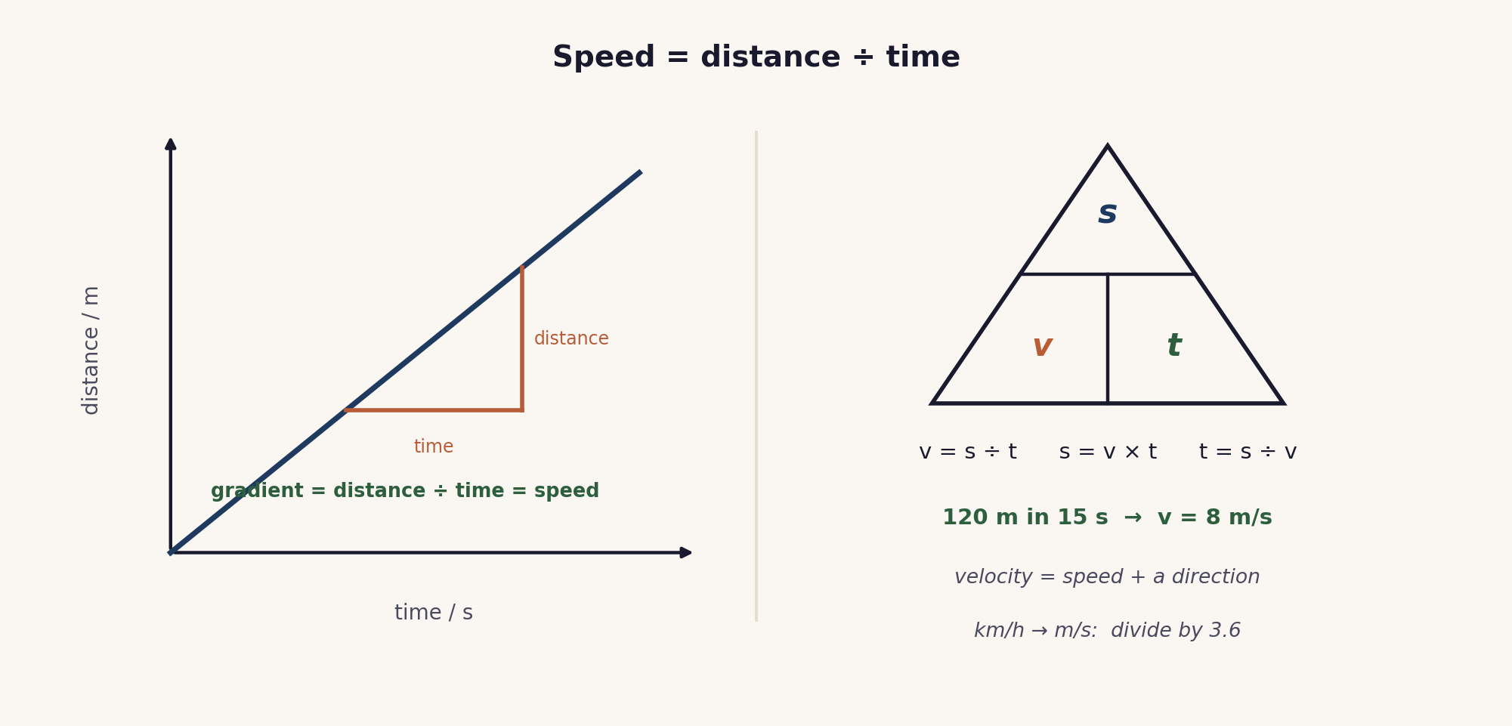
Name: ________________ Class: __________ Date: __________
Q1. Define (a) speed and (b) velocity. [2]

Q2. A car travels 240 m in 12 s at a steady rate. [3]
(a) Calculate its speed.
(b) State its velocity if it travels due east.

Q3. Convert and compare. [3]
(a) Change 72 km/h to m/s. (b) Change 15 m/s to km/h. (c) Which is faster: 90 km/h or 23 m/s?

Q4. A runner covers 600 m in 30 s, then a further 600 m in 60 s. [3]
(a) State the total distance. (b) State the total time. (c) Calculate the average speed for the whole run.

Q5. A train moves at a steady 30 m/s for 45 s. Calculate the distance it travels. [2]

Q6. (a) Explain the difference between speed and velocity. (b) A car goes around a roundabout at a steady speed. Explain why its velocity is still changing. [2]

Total: 15 marks. Original work by the TheLucidSTEM team. Written in the style of the papers; no past paper question is reproduced.
ANSWER KEY · FULL WORKED SOLUTIONS

Speed and velocity: answers
Q1. Definitions.
(a) speed is the distance travelled per unit time (a scalar).
(b) velocity is speed in a stated direction (a vector).
Q2. Steady car.
(a) v = s ÷ t = 240 ÷ 12 = 20 m/s.
(b) velocity = 20 m/s due east.
Q3. Convert and compare.
(a) 72 ÷ 3.6 = 20 m/s.
(b) 15 × 3.6 = 54 km/h.
(c) 90 km/h = 90 ÷ 3.6 = 25 m/s, which is greater than 23 m/s, so 90 km/h is faster.
Q4. Two stages.
(a) total distance = 600 + 600 = 1200 m.
(b) total time = 30 + 60 = 90 s.
(c) average speed = total distance ÷ total time = 1200 ÷ 90 = 13.3 m/s (not the mean of the two speeds, which would be 15 m/s).
Q5. Distance from s = v × t.
s = v × t = 30 × 45 = 1350 m.
Q6. Speed and velocity.
(a) speed is how fast only (a scalar); velocity is speed with a direction (a vector).
(b) on a roundabout the direction of travel keeps changing, so the velocity changes even though the speed is steady.
Marking note: award the unit mark only when a correct unit is given. In Q4, average speed must use total distance ÷ total time, not the mean of the speeds.

