WORKSHEET · CAMBRIDGE IGCSE PHYSICS 0625 · 1.2 MOTION (CORE, WITH EXTENDED)

Speed-time graphs and acceleration: practice
Six original questions on speed-time graphs and acceleration. Give a unit with every answer. Remember: on a speed-time graph a horizontal line is constant speed, and a = Δv ÷ Δt in m/s squared.
Name: ________________ Class: __________ Date: __________
Q1. On a speed-time graph, state what each of these shows: (a) a horizontal line above the time axis; (b) a line that slopes upwards. [2]

Q2. Define acceleration and give its unit. [2]

Q3. A car speeds up from rest to 24 m/s in 6 s. [3]
(a) Calculate its acceleration. (b) The car then holds a steady 24 m/s. What does the speed-time line look like during this time?

Q4. The speed-time graph below shows a journey. [4]
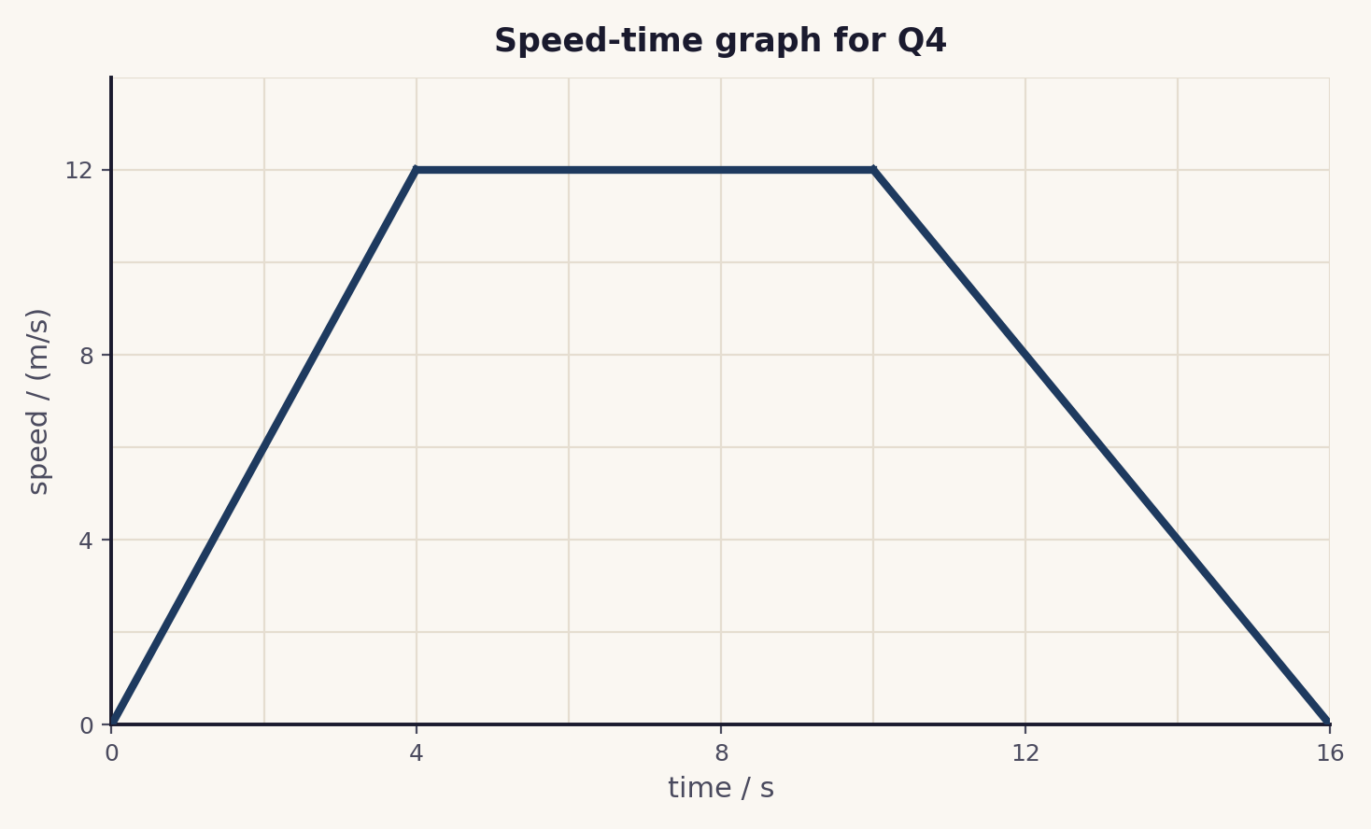
(a) Describe the motion between 4 s and 10 s. (b) Calculate the acceleration during the first 4 s. (c) At which times is the object at rest?

Q5. On a speed-time graph, what does a horizontal line mean? Explain how this differs from a horizontal line on a distance-time graph. [2]

Q6. Extended. A cyclist slows steadily from 15 m/s to 3 m/s in 4 s. Calculate the deceleration. [2]

Total: 15 marks. Original work by the TheLucidSTEM team. Written in the style of the papers; no past paper question is reproduced.
ANSWER KEY · FULL WORKED SOLUTIONS

Speed-time graphs and acceleration: answers
Q1. Reading the lines.
(a) a horizontal line above the time axis means a constant speed.
(b) a line sloping upwards means the object is accelerating (speeding up).
Q2. Definition.
acceleration is the change in velocity per unit time. Its unit is m/s squared (m/s²).
Q3. Speeding up.
(a) a = Δv ÷ Δt = 24 ÷ 6 = 4 m/s².
(b) the line is horizontal (flat) at a height of 24 m/s: constant speed.
Q4. Reading the graph.
(a) between 4 s and 10 s the line is horizontal at 12 m/s: constant speed.
(b) a = Δv ÷ Δt = 12 ÷ 4 = 3 m/s².
(c) at rest only at 0 s and at 16 s, where the speed is zero. Between these the object is always moving.
Q5. The horizontal-line trap.
on a speed-time graph a horizontal line means a constant speed. On a distance-time graph a horizontal line means the object is stationary. Read the axes first.
Q6. Extended: deceleration.
a = Δv ÷ Δt = (3 − 15) ÷ 4 = −3 m/s², so the deceleration is 3 m/s².
Marking note: award the unit mark only when m/s squared is given. In Q4(c), at rest means the speed is zero, not where the line is horizontal.

